<http://www.qababu.com/2017/07/how-to-execute-selenium-test-cases-from.html>

Steps:

Download Jenkins war file

# Good

# How to configure a Selenium project in Git & Jenkins using Eclipse

https://www.youtube.com/watch?v=BSTT--oFkuE

<http://www.qababu.com/2017/07/how-to-schedule-selenium-tests-in.html>

https://www.tutorialspoint.com/jenkins/jenkins_setup_build_jobs.htm

https://www.tutorialspoint.com/jenkins/jenkins_git_setup.htm

<file:///C:/Program%20Files/Git/ReleaseNotes.html>

<https://stackoverflow.com/questions/35863528/failed-to-connect-to-repository-error-performing-command-git-exe-ls-remote-h/41341483>

Build creation video:

<https://www.youtube.com/watch?v=RR0LabeUQ88>

<http://www.tothenew.com/blog/how-to-setup-jenkins-for-a-maven-project/>

run testing.xml in selenium

<https://www.youtube.com/watch?v=WojKMBgrtlE>

**…..**

# Run Tests from command line with Maven

[**https://www.youtube.com/watch?v=jaaYHCKtWmA**](https://www.youtube.com/watch?v=jaaYHCKtWmA)

**tutorial for build/job creation**

**https://www.youtube.com/watch?v=63HEKFh8T2c**

**V.good**

# How to run a maven GitHub project in Jenkins?

[**https://www.youtube.com/watch?v=BfJvxGs-HxQ**](https://www.youtube.com/watch?v=BfJvxGs-HxQ)

# Run Test Automation Scripts in Command Prompt With MAVEN

https://seleniumjava.com/2016/05/15/run-test-automation-scripts-in-command-prompt-with-maven/

# create job in Jenkins

<https://www.youtube.com/watch?v=OYZVKM3hbYE>

<https://www.youtube.com/watch?v=RR0LabeUQ88>

https://www.javafortesters.com/page/install/

[Jenkins ver. 2.89.4](https://jenkins.io/)

Git **2.20.1**) **64-bit**

**Jenkins credential:**

admin / 94e14e2b9dc94bbd944d0fb1d003d061

**Git Hub credential:**

<https://github.com/deepakgithub123/TestRepository>

# [deepakgithub123](https://github.com/deepakgithub123) /kismet!@90

……………..

Github download

<https://git-scm.com/>

# How to Download / Install Git & GitHub Desktop (Git Beginner Tutorial, first commit)

# https://www.youtube.com/watch?v=CFCh6Y-reiI

# Maven install

# https://maven.apache.org/install.html

# [run maven project in cmd line](https://stackoverflow.com/questions/33977187/how-i-run-maven-project-in-cmd-line)

https://stackoverflow.com/questions/33977187/how-i-run-maven-project-in-cmd-line

<https://www.youtube.com/watch?v=sirAFX1BN0o>

**Test maven version:**

mvn –version

**Run maven project in command line:**

mvn test

https://stackoverflow.com/questions/50767706/error-cannot-access-killable-while-compiling-the-code-with-selenium-java-3-11

# How to Download / Install Git & GitHub Desktop (Git Beginner Tutorial, first commit)

https://www.youtube.com/watch?v=CFCh6Y-reiI

# How to Install and Configure Git and GitHub on Windows

# https://www.youtube.com/watch?v=J_Clau1bYco

Install git

Don’t download GUI clients-becz we need cmd for

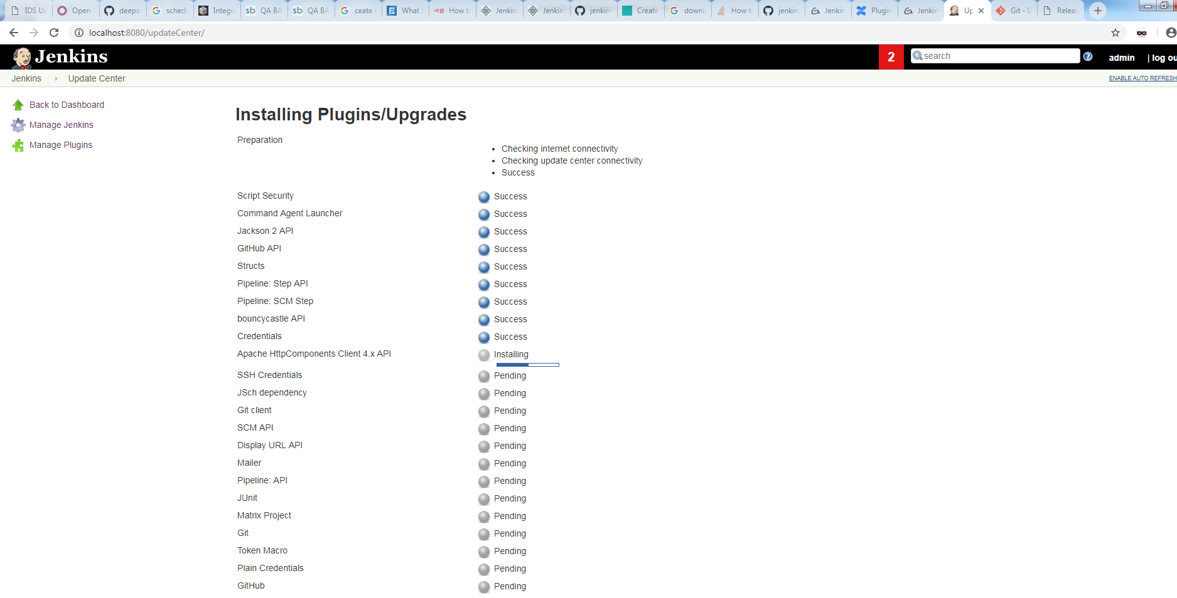

All ckecks are clickable

Fill review form without login--

Can the user see the review without login

Check that user can rate, review the product.

Check that customer is able to Review recent order and history of purchased items.

Check that the products should display an image, name, price and maybe customer ratings and number of reviews.

https://www.youtube.com/watch?v=J_Clau1bYco

…………………………………………………………………………………………………………………

1. Download below file for Jenkins

Generic java package(.war)

1. Then go to command prompt and start Jenkins serve in he windows machine
2. In command prompt go to where .war file is located then run command java -jar Jenkins.war

$(JENKINS_HOME)/TestPOMNav

C://Users/deepak.chamoli/.jenkins/TestPOMNav

<build>

<pluginManagement>

<plugins>

<plugin>

<groupId>org.apache.maven.plugins</groupId>

<artifactId>maven-surefire-plugin</artifactId>

<version>2.19.1</version>

<configuration>

<testFailureIgnore>true</testFailureIgnore>

</configuration>

</plugin>﻿

</plugins>

</pluginManagement>

</build>

Build issue solution:

<https://discuss.circleci.com/t/session-not-created-exception-chrome-version-must-be-62-0-3202-0/19258/6>

>>>>>>>>>>>>>>>>>>>

<https://www.journaldev.com/21326/testng-maven-surefire-plugin-configurations>

<build> <plugins> <plugin> <groupId>org.apache.maven.plugins</groupId> <artifactId>maven-surefire-plugin</artifactId> <version>2.21.0</version> <configuration> <!-- TestNG Suite XML files list for test execution --> <suiteXmlFiles> <suiteXmlFile>src/test/resources/testng.xml</suiteXmlFile> <suiteXmlFile>src/test/resources/test_parameters.xml</suiteXmlFile> </suiteXmlFiles> </configuration> </plugin> </plugins> </build>

??????????????????????????????????????????????????????????????

**GIT – Version control system**

**Distributed version control system**

**GIT is better than SVN**